**Practical No: 9**

**Aim :** Installation of Guest Operating System on Virtual Machine.

**Performed by:** Piyush Vanjari

**Class**: BCA-III SEM-VI

**Date:** 24/02/2025

# Download Ubuntu 19.10 ISO image to install on VirtualBox VM

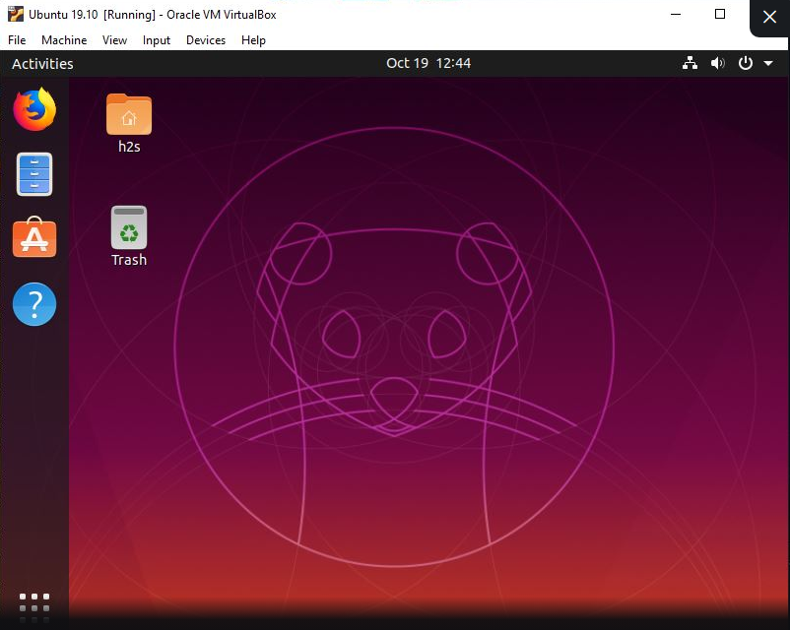

## Step 1: Download Ubuntu 19.10 ISO Image

As we know, it is not a Sisyphean task to get the Ubuntu latest Linux operating system ISO image. What we have to do, just go the official download page of the Ubuntu. For your convenience links are given below for each edition of Ubuntu 19.10.

## Step 2: Get the VirtualBox

If you already have VirtualBox on your Windows or Ubuntu system then simply move to the next step, or just go to the www.virtualbox.org and download one as per your host operating system. Know more about [VirtualBox installation.](https://www.how2shout.com/?s=virtualbox)

## Step 3: Create Virtual Machine on VirtualBox

1. Run **VirtualBox.**
2. Click on **New** button.
3. Type the operating system name **Ubuntu 19.10** and rest of settings will set automatically.  
   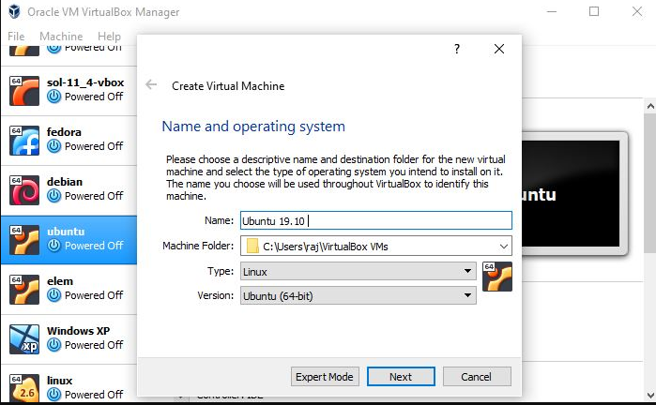
4. Set the amount of RAM for you Linux VM, as recommended one i.e **4GB.**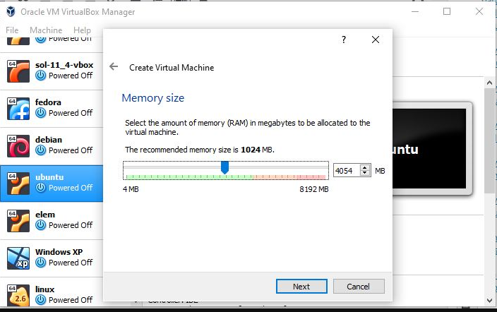
5. Now**create a virtual hard drive** for the same. Leave the default option for the hard disk file type that is**VDI** and then **Dynamic allocated.**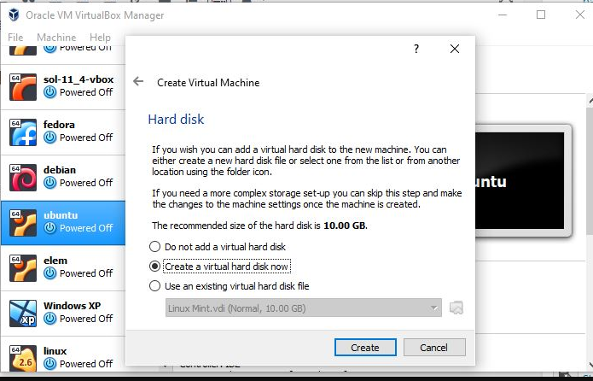
6. Use the scroll bar and set the disk size to **25 GB** or more and then click on the **create** button.  
     
   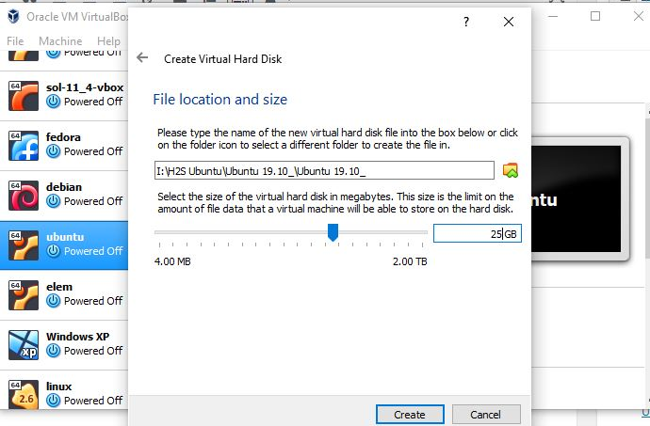
7. Finally, you will find your newly created**Ubuntu 19.10 virtual machine** on the left side panel of the VirtualBox. Select that and click on the **Settings** button on the given in the Menu.
8. Click on the **Storage** and **Empty CD drive** under the Storage Device.
9. Again on the CD icon that has given under the Attributes and selects “Choose Virtual Optical Disk File”.
10. Browse to the downloaded Ubuntu 19.10 ISO file and select that. And press the OK button.  
      
    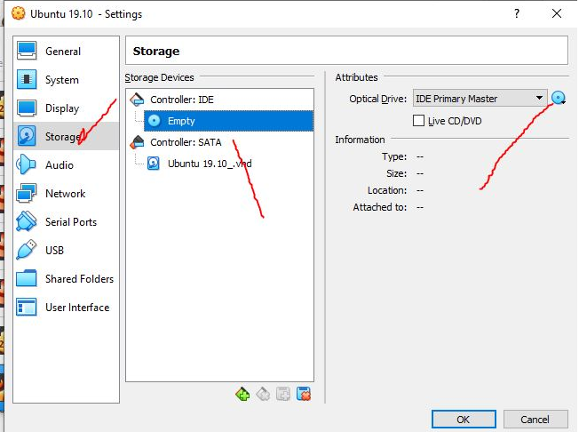

11.Now click on the **Start** button given on the VirtualBox top menu.

## Step 4: Ubuntu 19.10 Boot Menu

If you want to just try Live Ubuntu then select the Try Ubuntu option and for those want to install it can go for Install Ubuntu one. Here were are installing it.

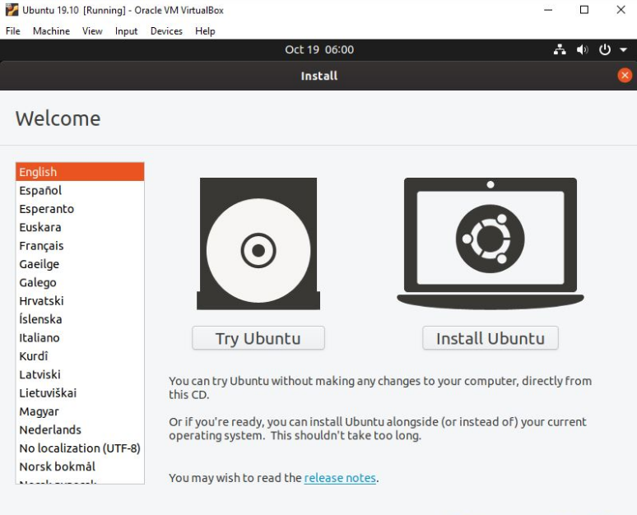

## Step 5: Select the Keyboard layout

As per the keyboard you are using, choose the one from the listed options, however, by default, it is set to US English.

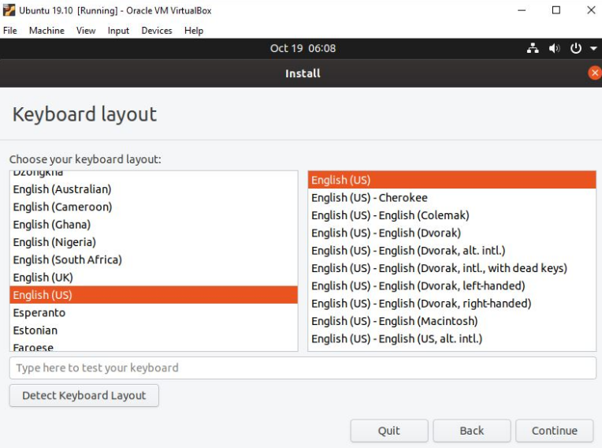

## Step 6: Normal or Minimal installation

If you don’t want office software, games, utilities, web browser and media players come as pre-installed on Ubuntu then select the minimal installation and check the other options before clicking on the continue button.

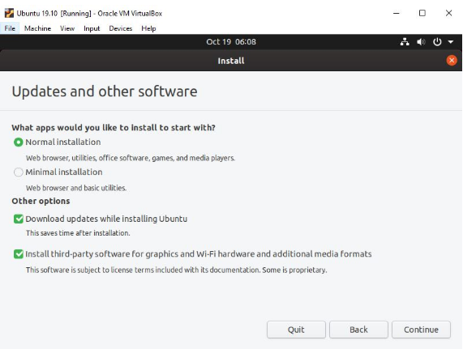

## Step 7: Create a Username and password

Simply type the name which you want to set as a username on your newly installed Ubuntu 19.10 along with the password.

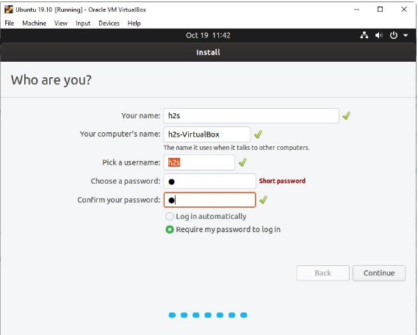

## Step 8: Erase disk and install Ubuntu or ZFS

As we know the new Ubuntu 19.10 comes with ZFS file system support, so, if you want to enable the snapshot functionality and want to test it then select the “**Experimental: Erase disk and use ZFS**” or just leave the default “**Erase disk and install Ubuntu**” one and click on the **Install Now**button

